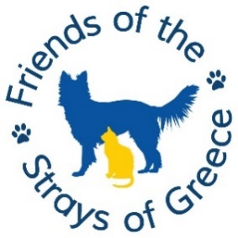

**SOG QUIZ NIGHT 2024**

Please support us by entering a team of up to 4 and encourage friends to make up a team too!  
Date: **Sunday 17th November 2024**

* Venue: **Merley House,** Merley Lane, Broadstone, Poole, Wimborne BH21 3AA
* Time: Arrival from **5pm for 6pm** start please
* Price: **£13.00 per person** to include food as detailed below
* **Tombola**, sales table and small prize raffle.
* 6 rounds of questions and a music round.
* Please **bring a £1 coin** to play **‘heads and tails’**
* Please bring a pen!
* **Quiz to finish at 9pm latest.**
* Please advise the following, no later than **Monday 11th November**

Team Name ………………… Contact Name …………..…………

Names of team members

Tel: …………………………. Email ………………………………

|  |  |  |  |
| --- | --- | --- | --- |
| **Ploughmans: Fresh mixed salad, pickled onion, coleslaw, orange slice, chutney, roll & butter** | **Qty** | **Baguette Fresh mixed salad** | **Qty** |
| Ham |  | Egg Mayo |  |
| Cheddar |  | Tuna Mayo |  |
| Stilton |  | Cheddar |  |
|  |  |  |  |
|  |  |  |  |

Please advise any dietary requirements and make a note of your order.

……………………………………………………………………………………

**Payment Options:**

1. **By cheque**, made payable to ‘**Friends of the Strays of Greece’** and provide on the night.
2. **By bank transfer** to Lloyds Bank, sort code 30-93-25,  
   **Account No** **38279968**, Name: Friends of the Strays of Greece.  
   Ref: **QUIZ.**  
   You can email your reservation to: [**SogQuiz@outlook.com**](mailto:SogQuiz@outlook.com)  
   Any queries, call **07889 539806 or 07776 175387**.  
     
   *We look forward to seeing you*.